**Environmental drivers of taxonomic and functional diversity of riparian plant communities in a modified landscape**

ABSTRACT

Human populations have a profound impact on the biodiversity of riparian plant communities, and understanding the nature and mechanisms of these impacts is central to river conservation and rehabilitation. Reduction of the inherent environmental heterogeneity in riverscapes by flow modification and land-use intensification is thought to cause degradation of riparian communities.

We sampled vegetation and assembled environmental data for 20 river reaches in south-east Queensland, Australia. Plant functional trait data collated from online databases and the ecological literature were used to characterise diversity in terms of ecological strategy. Our aim was to tease apart the environmental factors associated with taxonomic and functional trait diversity and the abundance of exotic species in riparian plant communities. We specifically tested the hypotheses that environmental heterogeneity is the dominant control on taxonomic and functional trait diversity, and that flow modification and land use intensification should reduce diversity and promote weedy invasion.

We found flow regime generally to be a useful predictor on diversity, but contrary to our expectations, hydrological metrics of environmental heterogeneity had limited explanatory power. Rivers which experienced seasonal, but temporally consistent flow regimes hosted the most species rich communities, and modification of flow regime towards temporal consistency was also associated with greater species richness. Also against expectation, proportional abundance of exotic species increased with hydrological heterogeneity. Functional diversity metrics showed unimodal relationships with some metrics of hydrological heterogeneity, but were only weakly predicted by flow modification and showed no relationship with land-use intensity.

Our observations suggest that rhythmicity in provision of resources and energy by streamflows may be more important than environmental heterogeneity in determining patterns of riparian plant diversity in south-east Queensland.

INTRODUCTION

Riparian ecosystems are highly biodiverse, provide important ecosystem services, and are the focus of substantial management effort worldwide (Naiman, Decamps & Pollock 1993; Palmer *et al.* 2009). Rapid development of catchments has changed fundamental processes which create and maintain biodiversity within riparian landscapes (Nilsson & Svedmark 2002), and as such, riparian management often takes place within this context of catchment modification. Wholesale vegetation clearing notwithstanding, regulation of river flow regimes, catchment land-use change and invasion by exotic plant species are considered key drivers of ecological change (Nilsson & Berggren 2000; Stromberg *et al.* 2007; Cooper *et al.* 2013). Maintaining indigenous plant assemblages and their associated ecosystem functions, and controlling invasive species are central goals in river rehabilitation and riparian conservation (Richardson *et al.* 2007).

Environmental heterogeneity is one of the major factors influencing spatial patterns of species diversity (Costanza, Moody & Peet 2011; Stein, Gerstner & Kreft 2014). According to classical niche-based theories of species co-existence (Chesson 2000), where each niche is associated with an optimal ecological strategy, structural complexity and steep resource and energy gradients between patches promote diversity by extending niche space and reducing niche overlap. More recently, niches have been characterised in trait-space: niches and their interrelationships are described by patterns of clustering of functional traits (any morphological, physiological or phenological feature measurable at the individual level; Violle *et al.* 2007), the values of which are optimised to a given set of environmental conditions (Adler *et al.* 2013). Thus the distribution of functional traits within a community can be expected to be patterned by the degree of heterogeneity in environmental conditions present. Describing communities in traitspace dissolves species distinctions and emphasises ecological strategies: what species do within their community and how they do it. In turn, metrics of diversity derived from functional traits provide a useful complement to taxonomic diversity metrics, as they allow a mechanistic characterisation of biodiversity-ecosystem functioning relationships (Hillebrand & Matthiessen 2009).

Much of the riparian ecology literature identifies fluvial hydrology and geomorphology as the dominant abiotic force structuring riparian ecosystems (Poff, Allan & Bain 1997; Bendix & Hupp 2000). The spatial and temporal heterogeneity inherent in fluvial processes is considered largely responsible for the complex biogeomorphology of riparian environments (Naiman *et al.* 2005; Corenblit *et al.* 2007). Sediments are scoured and deposited, some plants are washed away while others are watered; organic matter and woody debris moves through the system and propagules are dispersed. The spatial distribution of these processes within the fluvial landscape is contingent on the magnitude and frequency of the flow events that drive erosion and deposition processes, and the resultant morphology and sedimentology of fluvial landforms produced (Fryirs & Brierley 2012). This subsequently determines the extent to which different surfaces/landforms are inundated under a range of different flow conditions ((Hughes 1997). Temporal variability in flooding patterns adds a further layer of complexity by influencing the success of plant ecological strategies for a given patch. More frequently flooded patches are likely to support graminoids and rheophytes, while succession is likely to proceed further on patches which are less frequently disturbed (Corenblit *et al.* 2009). Soil moisture conditions are also strongly driven by fluvial hydrology in riparian environments, with further implications for plant community assembly (Nilsson & Svedmark 2002).

Intermediate disturbance-type unimodal relationships between fluvial disturbance and species richness (SR) are commonly described (e.g. Bendix 1997; Bendix & Hupp 2000; Lite, Bagstad & Stromberg 2005; Corenblit *et al.* 2007). Unimodal relationships between environmental heterogeneity and diversity are also hypothesised to occur as a result of ‘microfragmentation’ at high levels of heterogeneity (Tamme *et al.* 2010). Previous work on riparian plant communities has shown strong positive links between functional trait diversity and flow heterogeneity (Lawson et al. *in press*): relationships between functional dispersion and metrics of flow variability were mostly monotonic, with the exception of interannual variability in summertime flows, which showed a unimodal relationship.

Over half the world’s large river systems and countless smaller watercourses are affected by dams, weirs and diversions (Nilsson & Berggren 2000; Nilsson *et al.* 2005). While the effects of individual dams tend to be idiosyncratic (Mackay, Arthington & James 2014), flow regulation typically homogenises hydrographs by removing small-moderate flows, reducing flood peaks, altering seasonality and increasing predictability of flows (Graf 2006; Singer 2007). According to the magnitude and form of change to the flow regime, flow modification may result in reduced niche complexity in downstream riparian zones (Lloyd *et al.* 2004). In a recent comprehensive review of ecological responses to flow modification, Poff and Zimmerman (2010) found that 152 out of 165 reported decreased values for recorded ecological metrics. Invasion by exotic plants in response to flood reduction often results in extensive shifts in riparian plant assemblages and reduction of both taxonomic and functional diversity (Stokes 2008; Merritt & Poff 2010; Catford *et al.* 2011). Terrestrialisation of riparian plant communities has also been described in systems where low flow conditions dominate (Poff & Zimmerman 2010).

Human land use also has a profound effect on diversity and functioning in natural ecosystems. Land transformation for agricultural and silvicultural production, urbanisation and resulting habitat fragmentation have resulted in extensive losses of both alpha and beta diversity (Vitousek *et al.* 1997; Gerstner *et al.* 2014). This effect is often exacerbated by the entourage of exotic species brought by humans into the landscapes we occupy (Vitousek *et al.* 1996), local extirpation of indigenous species (Davis 2003) and stifling of successional processes (Catford *et al.* 2012) being common outcomes of plant invasion. A recent international meta-analysis linked land-use intensification to diminished functional redundancy and ability to respond to disturbance (Laliberté *et al.* 2010).

Environmental homogenisation of riparian landscapes by this triad of flow modification, land-use change and exotic invasion therefore has profound implications for riparian biodiversity. The environmental flows concept posits that given a solid understanding of the hydroecology of a given riparian assemblage, restoration of riparian ecosystems on regulated rivers can be facilitated by releasing engineered flows which support the indigenous ecology (Poff *et al.* 2010). The success of such endeavours in modified landscapes, however, is likely to be contingent on the relative contribution of flow modification and other pressures on riparian ecosystems. Functional trait approaches to characterising diversity provide the means to investigate the independent and combined effects of these pressures on the functional structure of riparian plant assemblages.

To this end, we used a functional trait diversity approach to examine vegetation responses to hydrological alteration in a modified landscape in south-east Queensland, Australia. Our aim was to tease apart the environmental factors associated with taxonomic and functional diversity and the abundance of exotic species in riparian plant communities. A set of hypotheses about environmental heterogeneity – diversity relationships guided our approach: 1a.) species richness and functional diversity increase and abundance of exotic species decreases monotonically with increasing hydrological heterogeneity; 1b.) species richness, functional diversity and abundance of exotic species show unimodal relationships with hydrological heterogeneity; 2.) species richness and functional diversity decrease and abundance of exotic species increases along gradients of increasing flow modification and catchment land-use intensity.

REGIONAL SETTING AND HYDROLOGY

The study was run across seven catchments in coastal south-east Queensland, Australia (-25.82º to -28.23º S, and 152.35º to 153.42ºE, see Fig 1). The dominant land-use in the region is agriculture, with approximately 40 % of the area under grazing, and 4 % used for cropping. Urbanisation is also extensive, particularly along the coast. Native vegetation within conservation estate or state forest comprises 20 % of the study area, and additional native vegetation remnants are common in steep terrain. This study area has a subtropical climate, and is influenced by both tropical and temperate weather patterns. Little variation in temperature is present throughout the region, although mean annual rainfall varies considerably, from 800 mm in the west to 1400 mm in the eastern coastal catchments (Bureau of Meteorology 2009). The majority of rainfall is associated with summer thunderstorms between January and March, although southerly weather systems during autumn and winter are also responsible for a substantial amount of precipitation. Precipitation patterns are associated with high year-on-year variability, and river discharge regimes in the region are typically unpredictable, with high coefficients of variation in mean daily flow (Rustomji, Bennett & Chiew 2009; Kennard *et al.* 2010). This said, substantial hydrological variability is represented across coastal south-east Queensland. Four of the twelve hydrological classes identified on the Australian continent by Kennard et al. (2010) are present in the area: perennial, stable baseflow; perennial, unpredictable baseflow; intermittent, unpredictable; and highly intermittent, unpredictable summer dominated.

River flow regimes throughout the study region are modified by dams, weirs, intra- and inter-basin water transfer, and unsupplemented water extraction. The majority of the dams were constructed by the mid-1970s and have a maximum capacity of less than 50,000 ML. Two substantially larger dams (Wivenhoe Dam – 1,150,000 ML and Hinze Dam – 165,000 ML) in the area were constructed during the 1980s. Mackay *et al.* (2014) compared historic daily discharge data with modelled predevelopment discharge data and found that flow modification by structures and diversions in south-east Queensland is diverse and system specific. Reduced flow variability is prevalent, and while increased perenniality in drier systems and altered low spell duration are also common, few other generalisations can be made about the effects of regulation on streamflows in the region (Mackay *et al.* 2014).

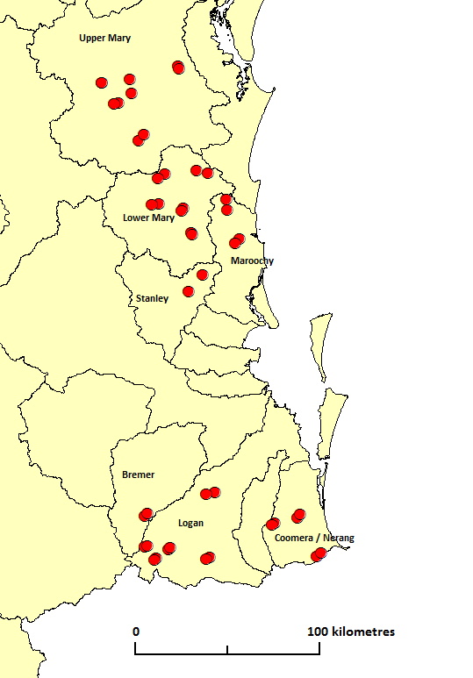

Figure 1. Study catchments and locations of field sites in south-eastern Queensland.

METHODS

The current study is an extension of a previous larger study (Arthington *et al.* 2012); the report describing the original study provides extensive detail not included here. Except where specified, all statistical analyses were performed using the R statistical programming environment (R Core Team 2015), and statistical significance was thresholded at alpha = 0.05.

*Site selection and vegetation sampling*

Riparian vegetation was surveyed between August and October in 2008, 2009 and 2010. Twenty river reaches were selected to sample the range of flow regime classes determined by a regional classification of flow regimes (see Mackay et al., 2014). Proximity to flow monitoring gauges with an associated recording history of >25 years was of primary importance. Duplicate surveys were made along each river reach as close as possible to the flow monitoring station (to give a total of 40 sites), but separated by at least 2 km. Sampling sites required 100 continuous metres of relatively intact riparian vegetation, which was not subjected to regular burning and had not been cleared in at least 20 – 30 years. Ideally sites were not currently grazed, although this restriction was relaxed somewhat given the extensive pastoral land use throughout the region.

Three transects were randomly placed at each site, running perpendicular to the river. Additional transects were conducted at three sites, where low vegetation densities occurred. Transects extended from the water’s edge to the macrochannel bank, or to a maximum of 50 m from the water’s edge. A standard sampling area was not used due to variability in vegetation structure, channel landforms and adjacent land uses. Site sampling areas were typically greater than 400 m2 but ranged from 260 – 1013 m2. All trees, shrubs, ferns rushes, and sedges within a 5 m band centred on the transect line were identified and counted. Species identifications were confirmed by the Queensland Herbarium.

*Describing stream hydrology and quantifying flow regulation*

Daily discharge data for each reach were obtained from Queensland Government Department of Natural Resources and Mines (DNRM) Water Monitoring Data Portal (https://www.dnrm.qld.gov.au/water/water-monitoring-and-data/portal). Thirty five year time series spanning 1975 – 2009 were obtained where possible. Missing data were infilled using the Time Series Manager module in River Analysis Package (Marsh, Stewardson & Kennard 2003), using linear interpolation for periods less than 15 days, or multiple regression using data from adjacent stream gauges. One site (Reynolds Creek) had substantial periods of missing data which could not be infilled by multiple regression, as the flow at this gauge is altered by Moogerah Dam. The record for this site was truncated to exclude the periods where data was missing. The shortest remaining period (34 days) was infilled by linear interpolation. Flow data for one site (Obi Obi Creek at Kidaman) was obtained from Water Quality Accounting (Queensland DNRM) as modelled gauge data derived from a calibration model for the Mary River catchment.

River Analysis Package was used to generate a set of 18 ecologically relevant hydrological metrics for each site, describing mean and interannual variability in the frequency, magnitude and duration and seasonal timing of high and low flows conditions. Table 1 provides definitions of these flow regime characteristics and describes their ecological importance and contribution to environmental heterogeneity. As a number of these metrics exhibited collinearity, we have included a principal components analysis of this data in the Supporting Information S1. Metrics of flow magnitude which had units ML / day were standardised by mean daily flow to allow for comparison between different river cha­­nnel sizes. These metrics therefore represent ratios of flow magnitude to mean daily flow.

The extent of flow regulation at a given gauge site was characterised by the percentage deviation of each metric from the same metric generated using modelled pre-development flow data. These modelled pre-development daily discharge data were obtained from a generic integrated water quantity and quality simulation model (IQQM) developed for the region (Simons, Podger & Cooke 1996). IQQM data were available only for the period up to 1999, so data from the timeframe 1975-1999 were used for comparison.

Table 1. Hydrological variables used as metrics of fluvially induced environmental heterogeneity in the riparian zone (adapted from Lawson et al. 2015b).

|  |  |  |  |
| --- | --- | --- | --- |
| **Parameter** | **Abbreviation** | **Units** | **Description** |
| *Frequency, magnitude and duration of floods and dry spells* | | | |
| Mean magnitude of high spells*  Mean magnitude of low spells* | HSPeak  LSPeak | dimensionless  dimensionless | Together, these metrics characterise the frequency, magnitude and duration of floods and dry spells. Extreme low or high flows contribute to spatial environmental heterogeneity, in that their effects (flooding disturbance, soil moisture stress) are spatially variable throughout the riparian landscape.  High flow spells are periods of flow above the 95th percentile; low flow spells are periods of flow below the 5th percentile. HSPeak and LSPeak describes the mean magnitude of highest and lowest flows during high and low spells throughout the record, respectively. MDFAnnHSNum and MDFAnnLSNum describe the mean annual frequency of high and low spells. HSMeanDur and LSMeanDur describe how long flow events last.  Coefficients of variation (CV) of these metrics between years characterise temporal heterogeneity in flow patterns. |
| CV of all years’ mean high spell magnitude  CV of all years’ mean low spell magnitude | CVAnnHSPeak  CVAnnLSPeak | dimensionless  dimensionless |
| Mean of all years’ number of high spells  Mean of all years’ number of low spells | MDFAnnHSNum  MDFAnnLSNum | year-1  year-1 |
| CV of all years’ number of high spells  CV of all years’ number of low spells | CVAnnHSNum  CVAnnLSNum | dimensionless  dimensionless |
| High spell mean duration  Low spell mean duration | HSMeanDur  LSMeanDur | days  days |
| CV of all years’ high spell mean duration  CV of all years’ low spell mean duration | HSMeanDur  LSMeanDur | dimensionless  dimensionless |
| *Baseflow index* | | | |
| Baseflow index  CV of all year’s baseflow index | BFI  CVAnnBFI | dimensionless  dimensionless | Baseflow index is calculated using the ratio of flow during average conditions to total flow. It is a useful metric of perenniality of water availability, in that it is maximised when average flow conditions dominate, and minimised when total flow is dominated by above average flow events. Thus higher baseflow systems experience more homogeneous flows. |
| *Colwell’s indices* | | | |
| Constancy of monthly minimum daily flow | C_MinM | dimensionless | Colwell’s indices provide a measure of the seasonal predictability of flow events, and as such are a direct measure of temporal heterogeneity of flow patterns.  Constancy (C) measures uniformity of flow across seasons, and is maximised when flow conditions do not differ between seasons. Contingency (M) is a measure of interannual uniformity in seasonal flow patterns, and is maximized when seasonal patterns of flow are consistent between years.  We generated Colwell’s indices for both minimum and maximum flows conditions. |
| Contingency of monthly minimum daily flow | M_MinM | Dimensionless |
| Constancy based on monthly maximum daily flow | C_MaxM | Dimensionless |
| Contingency based on monthly maximum daily flow | M_MaxM | dimensionless |
| *Flow seasonality* | | | |
|  |  |  | These metrics describe the average magnitude and temporal variability in mean daily flows for each season (dry = May to October, wet = November to April). Averages and coefficients of variation are calculated across yearly means. Seasonal average mean daily flows were standardised by overall mean daily flow, so actually represent the ratio of mean daily flow in a given season to the total mean daily flow. |
| Average mean daily dry season flow *  Average mean daily wet season flow * | MDFMDFDry  MDFMDFWet | dimensionless  dimensionless |
| CV of mean daily dry season flow  CV of mean daily dry season flow | CVMDFDry  CVMDFWet | dimensionless  dimensionless |

*Other environmental variables*

Data on upstream land use were obtained via the Queensland Land Use Mapping Program (QLUMP) and dataset (Witte *et al.* 2006). This data was generated from surveys conducted in 1999 and 2006. Land use was categorised according to the Australian Land use and Management Classification version 6 (BRS 2002), which differentiates conservation and low impact land uses from intensive land uses. Percentages of upstream land use were calculated as: production from relatively natural environments (forestry, grazing natural vegetation), dryland agriculture and plantations (e.g. cropping, horticulture, grazing pasture), irrigated agriculture (e.g. irrigated cropping, horticulture), conservation and natural environments (e.g. national park) and intensive uses (e.g. residential and industrial uses). We then used inverse distance weighting to weight each land use according to its proximity to the stream, following Petersen et al. (2010).

Climate data were obtained from eMast/TERN, at a resolution of 0.01 degrees (Hutchinson, Kesteven & Tingbao 2014). Bioclimatic variables representing annual trends, seasonality and extremes were calculated following the BIOCLIM framework (Busby 1991). The resulting set of 19 climate variables were strongly collinear, PCA was used to identify a subset of 6 variables which represented over 90 % of the variation in the data. Soil data were taken from the CSIRO Soil and Landscape Grid of Australia, at a resolution of 3 arc seconds (~ 3 m) (Rossel *et al.* 2014 a b c d e f g h i j k; Wilford *et al.* 2014).

*Trait selection and dataset assembly*

We assembled a dataset of 6 continuous (specific leaf area, leaf area, maximum canopy height, seed mass, wood density and flowering duration) and 1 categorical (growth form) functional traits with which to calculate functional diversity. These traits collectively describe central trade-offs associated with ecological strategies of riparian plants (functional responses), as well as flow-on effects of species on ecosystem functioning (functional effects). Table 2 provides further description of the utility of each of these traits in characterising the functional ecology of riparian vegetation communities.   
Data was taken from published literature, private and published trait datasets, and Australian flora texts. Where multiple records for a trait were found, values were removed if they were measured at sites with an environment substantially different from south east Queensland. With the exception of maximum height, for which the highest value was used, the remaining values were averaged to provide a single value for each species-trait combination. Not all species-trait combinations could be assigned data, so to reduce biases associated with analyses of incomplete trait datasets (Penone *et al.* 2014), only species with fewer than 3 missing trait values (174 / 260) were retained for the analysis. The remaining missing values were imputed using a non-parametric random forests approach (*missForest* package for R, Stekhoven & Buhlmann, 2012). Dataset density information can be found in the Supporting Information S1.

Table 2. Rationale for selection of functional response and effect traits as descriptors of riparian plant community functional diversity.

|  |  |  |  |
| --- | --- | --- | --- |
| **Trait** | **Definition** | **Functional responses & inherent trade-offs** | **Functional effects** |
| *Growth form* | Categorical description of morphology: tree, shrub, woody climber, herbaceous climber, graminoid, herb. | Differential responses to mechanical and biochemical stresses associated caused by flooding; different strategies for coping with drought and heat stress. | Differential biogeomorphic effects on fluvial landform cohesion and sediment deposition. |
| *Specific leaf area (SLA)* | Ratio of one-sided leaf area to oven dry mass (cm2 / g). | SLA is associated with leaf construction cost, photosynthetic rate and carbon : nitrogen economics. Indicator of ecological strategy under favourable vs. stressful conditions(Wright *et al.* 2004). | Affects ecosystem productivity and nutrient recycling (Wright *et al.* 2004). |
| *Leaf area* | One-sided leaf area (cm2). | Shade tolerance (larger leaves) vs. enhanced thermal regulation ability in hot, dry conditions (smaller leaves) (Cornelissen *et al.* 2003). | May influence flow resistance of vegetation (and therefore fluvial erosion / deposition) when inundated. |
| *Maximum canopy height* | Height above ground of apical meristem (m). | Affects ability to tolerate mechanical disturbances such as flooding and maintain xylem integrity in dry conditions (Westoby & Wright 2006). | Determines coarse physical structure of plant community. Surrogate for competitive ability: taller plants receive more light but must construct and maintain support structures (Falster 2006). |
| *Seed mass* | Combined mass of the seed coat, endosperm and embryo (g). Excludes dispersal structures. | Larger seed mass confers ability to establish in unfavourable conditions (Leishman *et al.* 2000). Also related to seed buoyancy (Carthey 2014, *unpublished data*). | Seeds may be an important food source for animals. |
| *Wood density* | Oven dry mass divided by green volume (g/cm3) | Dense wood tissue confers mechanical strength, but is energetically expensive to construct. Wood density influences ability to tolerate drought stress and disturbance (Telewski 1995; Preston, Cornwell & Denoyer 2006; Lawson *et al*. 2015). | Regulates decomposition rate; this affects nutrient cycling and determines the residency time of woody debris in the fluvial system (Mackensen, Bauhus & Webber 2003). |
| *Flowering period length* | Proportion of the year spent in flower (proportion, dimensionless). | Indicates species’ ability to respond reproductively to favourable conditions. | Flowers may be an important food source for animals. |

*Calculating functional diversity, species richness and proportional abundance of exotics*

Functional richness (FRic) and functional divergence (FDiv) are complementary metrics of functional trait diversity, which together, describe the range and distribution of trait values in a community (Villéger, Mason & Mouillot 2008). Functional evenness is also included in the framework introduced by Villéger et al. (2008) but has since shown limited ability to describe change in functional compositon across environmental gradients (Pavoine & Bonsall 2011; Mason *et al.* 2012). FRic represents the volume of the convex hull of trait values in a given community while FDiv provides information about the abundance distribution of trait values across this range.

We calculated functional richness and abundance-weighted functional dispersion (FDis) of vegetation communities at each site, using the *FD* package for R (Laliberté & Legendre 2010). Gower’s method, which scales traits by their range, was used to generate the required dissimilarity matrix, and Cailliez’s correction was applied to render the matrix euclidean. We transformed FRic and FDis into standardised effect sizes (SES): SES = (obs – nullExp) / sd(nullExp), where obs is the observed functional diversity value and nullExp and sd(nullExp) are the mean and standard deviation of the expected functional diversity in 999 randomized communities (Gotelli & Rohde 2002). The null model for comparison with FRic was generated using the trial-swap algorithm (Miklós & Podani 2004) in the *picante* package (Kembel *et al.* 2010) to remove dependence on species richness. The null model for comparison with FDis was generated by randomizing abundances among species but within plots (using the resamp.2s function in *spacodiR*) (Eastman, Paine & Hardy 2011), to generate a metric of pure functional divergence. The resulting indices, FRic.SES and FDis.SES, have greater power to detect community assembly processes than their unstandardized counterparts (Mason *et al.* 2013).

Where required, trait values were normalised by either log10 (SLA, seed mass) or square root (leaf area, maximum height, flowering duration) transformation prior to analysis. Wood density was not transformed. Summary statistics for the trait dataset are shown in the Supporting Information S1.

Species richness values were standardised by sampling area to account for differences in sampling effort. Abundance of exotic species was calculated as the number of exotic individuals divided by the total number of individuals counted at each site.

*Constructing variance partitioning models*

We used a variance partitioning approach to assess the individual contributions of river flow regime, flow modification, land use, climate and soil properties to modelling variation in riparian plant SR, functional diversity and exotic abundance. Exotic proportional abundance was also included as an explanatory variable for SR and functional diversity metrics.

The following process was used to derive an optimal set of environment-diversity models for variance partitioning analysis (Legendre 2007):

We first generated minimal multiple regression models for each set of environmental variables (i.e. descriptors of flow regime, flow modification, land use etc.): for each individual dependent variable, the full set of explanatory variables was reduced to the subset which showed statistically significant (p < 0.05) linear or quadratic relationships. Second order AIC was used to determine whether the linear or quadratic term better explained variation in the dependent variable (*MuMIn* package for R, Barton, 2012; Burnham & Anderson 2002). For each set of environmental variables, variance explained by significant univariate models was partitioned by partial regression using the varpart function in R (*vegan* package, Oksanen *et al.* 2013). Multiple regression models were derived from the combinations of variables with the highest adjusted R2 values (Peres-Neto *et al.* 2006). These multiple regression models optimally combine the variation explained by all significant univariate models.

The four best multiple regression models were fed into a second variance partitioning analysis, and adjusted R2 was used to estimate the proportion of variation jointly and independently explained by each environmental model.

RESULTS

Below we describe the patterns of variation in species richness, exotic abundance, functional richness and functional dispersion of riparian plant communities, as they relate to metrics describing river hydrology, flow modification, land use, climate and soil properties.

Due to considerable collinearity in the environmental dataset, description of univariate relationships is generally limited here to variables selected by variance partitioning for inclusion in the final multiple regression models. Statistics for the all statistically significant univariate regression models can be found in the Supporting Information S2. The adj. R2 value shown in variance partitioning Venn diagrams (Figs 2-5b) may not correspond directly to the sum of its fractions as represented in Figs 2-5a., as negative R2 values (not shown in Figs 2-5a) can result from the adjustment algorithm. All R2 values given in the text are adjusted R2.

*Environmental drivers of variation in species richness*

A substantial portion of variation in species richness across the study area (0.787) could be explained by a combination of models describing hydrology, flow modification, climate and soil conditions (Fig 2a,b). Hydrology and flow modification were co-dominant, while climate and soil variables contributed a minor component of variation; variation explained by the climate model was almost completely subsumed by the hydrological model. Land use and climate were also associated with SR but independently explained no variation (not shown in Fig 2a, but see Supporting Information for regression statistics). Increased SR in response to these conditions could not be explained by an increased number of exotic species present, and although SR did decrease with exotic proportional abundance (R2 = 0.115) (see Supporting Information S1), exotic abundance did not independently explain variation in SR.

Species richness was highest when minimum flow conditions were unevenly distributed throughout the year (C_MinM, R2 = 0.237, Fig 2c), and where these seasonal patterns of minimum flows were consistent between years (M_MinM, R2 = 0.129, Fig 2d). Richness declined with increasing duration of high flow periods (HSMeanDur, R2 = 0.290, Fig 2e), but increased somewhat as these high flow periods became more frequent (MDFAnnHSNum, R2 = 0.106, Fig 2f). Increased dry season flows due to flow modification were weakly associated reduced SR (MDFMDFDry.mod, R2 = 0.117, Fig 2g). Alterations to seasonal consistency of minimum flow patterns had a strong effect (M_MinM.mod, R2 = 0.412,Fig 2h), and corroborated the trend observed in Fig 2d: SR increased as patterns of monthly minimum flows became more consistent throughout the hydrological record. With respect to climate, SR was greater at sites which experienced higher rainfall (clim_pwet, R2 = 0.390, Fig 2i) and less variable temperature regimes (clim_tsea, R2 = 0.349, Fig 2j). Soils which contained more organic carbon (soil_soc, R2 = 0.202, Fig 2j) and higher silt content (soil_slt, R2 = 0.239, Fig 2k), lower total phosphorus (soil_pto, R2 = 0.110, Fig 2l) and lower available water capacity (soil_awc, R2 = 0.203, Fig 2m) supported richer communities.

The data did not support hypothesis 1a, that rivers with more heterogeneous flow regimes host communities with higher SR, or hypothesis 1b, that there is a unimodal relationship between SR and flow heterogeneity. Further, these results oppose hypothesis 2 (that SR and functional diversity should decrease and abundance of exotic species should increase along gradients of increasing flow modification and catchment land-use intensity), given that rivers which experienced more consistent patterns of minimum flows hosted richer plant communities.

*Environmental drivers of functional richness (FRic.SES)*

Variation in FRic.SES was best explained by a combination of hydrological and soil models (variation explained by the combined model = 0.405) (Fig 3a,b), of which the hydrological model gave the most explanatory power. Soil variables independently explained a small fraction of variation, and while flow modification and climatic variables were also associated with FRic.SES, neither model explained any variation independently.

FRic.SES was distributed unimodally across gradients of interannual variability in baseflow index (CVAnnBFI, R2 = 0.170, Fig 3c); the modelled slope increased steeply at the lower end of the gradient but was only somewhat reduced from the peak by the top of the gradient. Greater frequency of high flow periods was associated with lower functional richness (MDFAnnHSNum, R2 = 0.142, Fig 3d). FRic.SES also declined as rainfall (clim_pwet, R2 = 0.246, Fig 3e), soil total nitrogen (soil_nto, R2 = 0.144, Fig 3f) and soil organic carbon (soil_soc, R2 = 0.257, Fig 3g) increased.

Hypothesis 1a was not supported, given that reduced functional richness was associated with increasing frequency of high flows. Hypothesis 1b was supported by a significant unimodal relationship interannual variability in baseflow (Fig 3c) and functional richness (delta AICc between linear and quadratic models = 3.70). Although not selected for the final hydrological model, mean and interannual variability in duration of high flow periods (HSMeanDur, CVAnnHSMeanDur) also showed significant unimodal relationships with FRic.SES (R2 = 0.213, 0.182, respectively; Supporting Information S1). Hypothesis 2 was not supported: we found no effect of either land use or flow modification on functional richness, except a weak relationship with modification of dry season mean daily flow (Supporting Information S1).

*Environmental drivers of functional divergence (FDis.SES)*

FDis.SES varied substantially across the study area (3.96 standard deviations of the null distribution), and was associated with gradients of hydrology, flow modification, climatic and soil conditions. The soil model explained 0.483 of the of variation in FDis.SES; hydrology, flow modification and climatic models did not independently explain further variation (Fig 4a,b).

Rivers with moderate seasonality of maximum flows tended to support communities with high functional divergence (C_MaxM, R2 = 0.321, Fig 4c). The entire range of FDis.SES was represented by rivers associated with highly seasonal patterns of maximum flows (C_MaxM), however. As with functional richness, FDis.SES declined with increasing frequency of high flows (MDFAnnHSNum, R2 = 0.112, Fig 4d). Functional divergence also varied with flow modification affecting high flow frequency (MDFAnnHSNum.mod, R2 = 0.144, Fig 4e): lower flooding frequency tended to be associated with higher functional divergence. Also tracking trends observed for FRic.SES, FDis.SES declined with increasing rainfall (clim_pwet, R2 = 0.141, Fig 4f), soil total nitrogen (soil_nto, R2 = 0.111, Fig 4g) and soil organic carbon (soil_soc, R2 = 0.344, Fig 4h).

Environmental heterogeneity (as indicated by high flow frequency) was associated with lower functional divergence (Fig 4d,e), opposing the prediction made in hypothesis 1a, while the unimodal relationship with constancy of maximum flows (Fig 4c) provided some support for hypothesis 1b (delta AICc between linear and quadratic models = 10.08). Scant evidence to support hypothesis 2 was found: as with FRic.SES, a weak but significant relationship was present between FDis.SES and dry season mean daily flow (see Supporting Information S1).

*Environmental drivers of variation in proportional abundance of exotic species*

Variation in exotic species abundance was jointly explained by hydrology, land use, soil and climatic models (0.665 of variation explained by the combined model) (Fig 5a,b). Hydrological models (0.581 of variation explained) and land use (0.515 of variation explained) models were dominant. Two individual metrics of flow modification had significant relationships with exotic abundance (C_MinM.mod, R2 = 0.124; LSPeak.mod, quadratic R2 = 0.105), but these effects were strongly influenced by outlying values and the flow modification model combining these metrics explained no variation independently.

Exotic abundance closely tracked interannual variability in baseflow index (CVAnnBFI, R2 =0.412, Fig 5c), and also rose as maximum flows became more uniformly distributed across seasons (i.e. a lack of flow seasonality) (C_MaxM, R2 = 0.157, Fig 5d). We found a trough-shaped relationship between interannual variability in dry season flows and exotic abundance (CVMDFDry, R2 = 0.412, Fig 5e), although the lower end of the distribution was data-poor and may have been unduly influenced by values for a single pair of sites. Throughout the centre and upper ranges of the distribution, however, exotic abundance increased strongly with interannual variability in dry season flow. Exotic abundance also increased with interannual variability in high spell duration (CVAnnHSMeanDur, R2 = 0.129, Fig 5f). The proportion of the upstream catchment used for irrigated agricultural production was a strong positive predictor of exotic abundance (production_irrigated, R2 = 0.37, Fig 5g), as was production from relatively natural environments, although somewhat less so (production_natural, R2 = 0.232, Fig 4h). Exotic abundance declined as dry season precipitation increased (clim_pdry, R2 = 0.207, Fig 5i), increased with soil pH (soil_phc, R2 = 0.242, Fig Xj), and decreased with soil depth to hard rock (soil_der, R2 = 0.140, Fig 5k).

With respect to hypothesis 1a, we found the opposite of expected: hydrological heterogeneity (as measured by CVAnnBFI, CVMDFDry and CVAnnHSMeanDur) appears to be associated with higher exotic abundance. These relationships did not exhibit unimodality. Production land uses were associated with higher exotic abundance, supporting hypothesis 2.

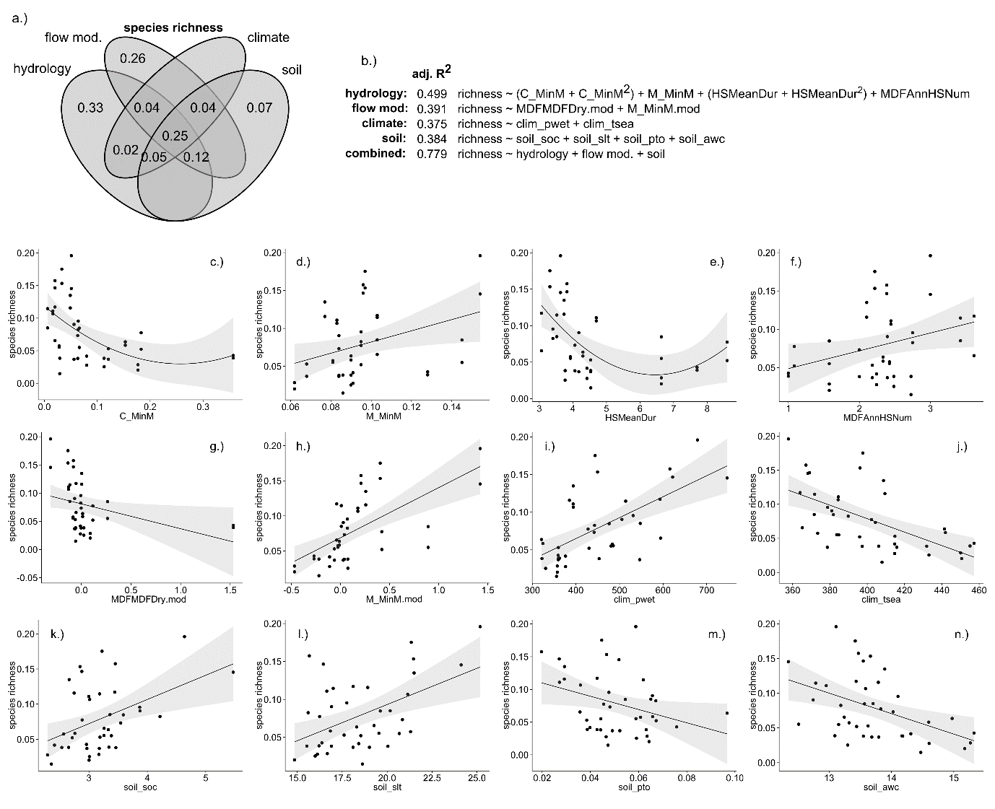

Figure 2. Environmental drivers of area-standardised species richness (units = species per m2) in riparian plant communities. a.) variance partitioning Venn diagram. Numbers within the diagram represent adjusted R2 (adj. R2) values associated with each fraction of variation; b.) multiple regression models representing each set of environmental conditions, and their optimal combination. Quadratic terms are enclosed in parentheses. Selected univariate relationships between species richness and environmental variables describing c.) constancy of monthly minimum daily flow (C_MinM); d.) contingency of monthly minimum daily flows (M_MinM); e.) mean duration of high flow periods (HSMeanDur, days); f.) mean annual frequency of high flow periods (MDFAnnHSNum); g.) modification of dry season mean daily flow (MDFMDFDry.mod, % change); h.) modification of contingency of monthly minimum daily flows (M_MinM.mod, % change); i.) precipitation in the wettest quarter of the year (clim_pwet, mm); j.) temperature seasonality (clim_tsea, standard deviation * 100); k.) soil organic carbon (soil_soc, %); l.) soil silt content (soil_slt, %); m.) soil total phosphorus (soil_pto, %); n.) soil available water capacity (soil_awc, %). Species richness is presented as standardised by plot area. Fitted lines depict ordinary least-squares regression models. Shaded areas depict the smoothed 95% confidence interval around the regression model.

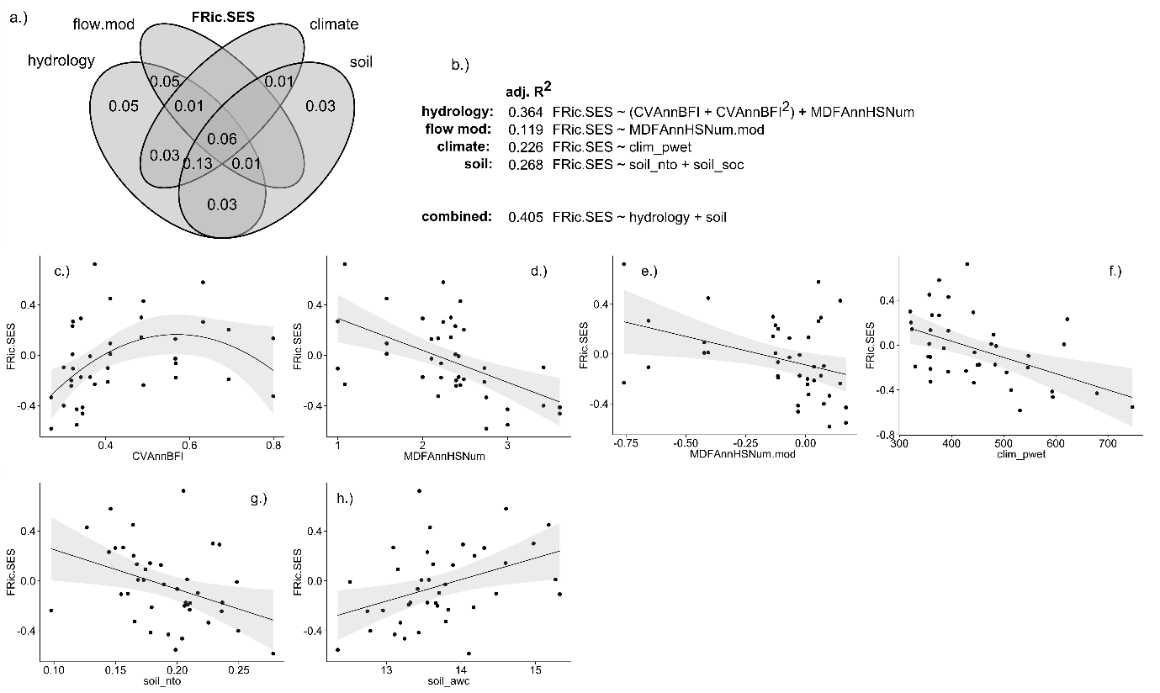

Figure 3. Environmental drivers of standardised effect size functional richness (FRic.SES) in riparian plant communities. a.) variance partitioning Venn diagram. Numbers within the diagram represent adjusted R2 (adj. R2) values associated with each fraction of variation; b.) multiple regression models representing each set of environmental conditions, and their optimal combination. Quadratic terms are enclosed in parentheses. Selected relationships between FRic.SES and environmental variables describing c.) interannual variability in baseflow (CVAnnBFI); d.) mean annual frequency of high flow periods (MDFAnnHSNum); e.) modification of mean annual frequency of high flow periods (MDFAnnHSNum.mod, % change); f.) precipitation in the wettest quarter (clim_pwet, mm); g.) soil total nitrogen (soil_nto, %); h.) soil organic carbon (soil_soc, %). Fitted lines depict ordinary least-squares regression models. Shaded areas depict the smoothed 95% confidence interval around the regression model.

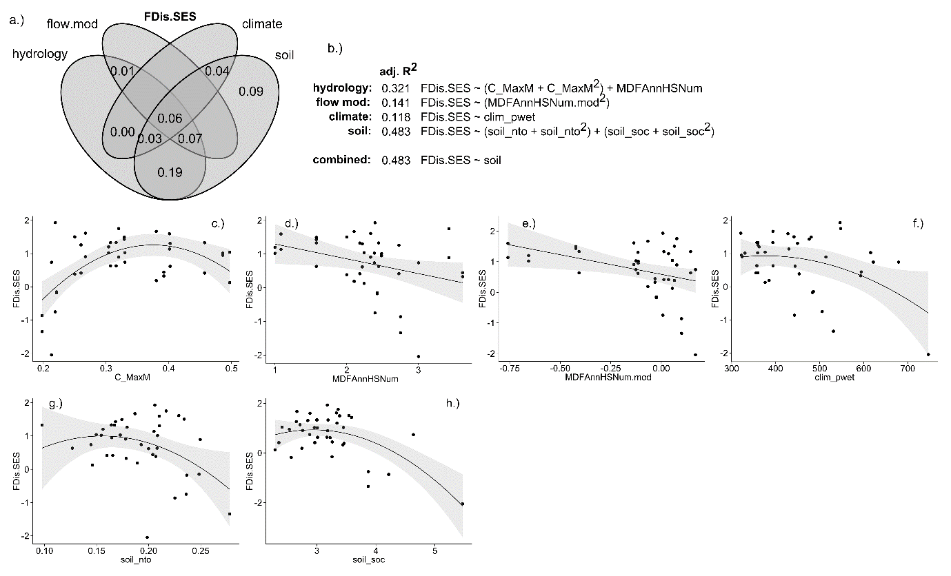

Figure 4. Environmental drivers of standardised effect size functional dispersion (FDis.SES) in riparian plant communities. a.) variance partitioning Venn diagram. Numbers within the diagram represent adjusted R2 (adj. R2) values associated with each fraction of variation; b.) multiple regression models representing each set of environmental conditions, and their optimal combination. Quadratic terms are enclosed in parentheses. Selected relationships between FDis.SES and environmental variables describing c.) constancy of monthly maximum daily flows (C_MaxM); d.) mean annual frequency of high flow periods (MDFAnnHSNum); e.) modification of mean annual frequency of high flow periods (MDFAnnHSNum.mod, % change); f.) precipitation in wettest quarter (clim_pwet, mm); g.) soil total nitrogen (soil_nto, %); h.) soil organic carbon (soil_soc, %). Fitted lines depict ordinary least-squares regression models. Shaded areas depict the smoothed 95% confidence interval around the regression model.

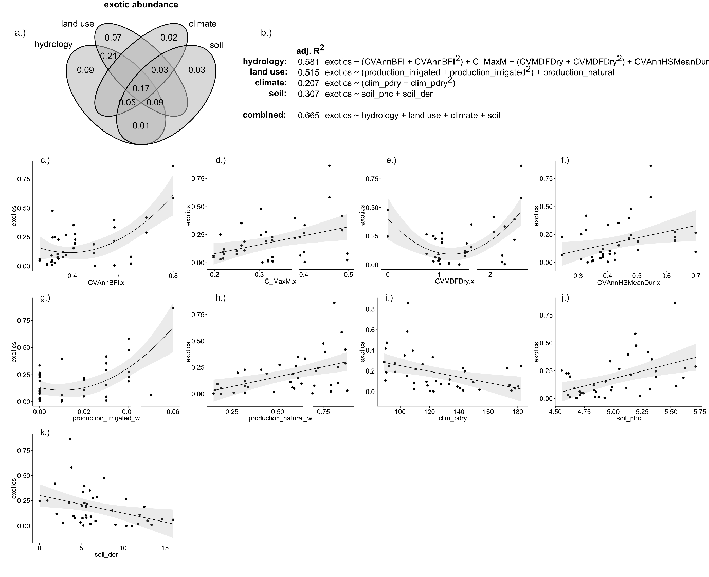

Figure 5. Environmental drivers of the proportional abundance of exotic species in riparian plant communities. a.) variance partitioning Venn diagram. Numbers within the diagram represent adjusted R2 (adj. R2) values associated with each fraction of variation; b.) multiple regression models representing each set of environmental conditions, and their optimal combination. Quadratic terms are enclosed in parentheses. Selected relationships between exotic abundance and environmental variables describing c.) interannual variability in baseflow index (CVAnnBFI); d.) constancy of monthly maximum daily flows (C_MaxM); e.) interannual variability in dry season mean daily flow (CVMDFDry); f.) interannual variability in mean duration of high flow periods; g.) proportion of catchment used for irrigated agricultural production (production_irrigated, geographically weighted %); h.) proportion of catchment used for production from relatively natural environments (production_natural, geographically weighted %); i.) precipitation in the driest quarter (clim_pdry, mm); j.) soil pH (soil_phc, %); k.) depth of regolith (soil_der, m to hard rock). Fitted lines depict ordinary least-squares regression models. Shaded areas depict the smoothed 95% confidence interval around the regression model.

DISCUSSION

We proposed that generation of niche complexity by spatially and temporally heterogeneous environmental conditions is the dominant control on diversity in riparian plant communities. Under this framework, suppression of natural environmental heterogeneity by human modification of river flow regimes and catchment landscapes would result in lower diversity (Poff *et al.* 1997, 2010). This niche-oriented model of riparian plant diversity received mixed support in our study: species richness (SR) in fact decreased as hydrological conditions became more heterogeneous, and flow homogenisation by dams was associated with greater SR. Although abundance of exotic species did increase with the proportion of surrounding land used for agricultural or silvicultural production, there was no relationship between exotic abundance and flow modification, and negative relationships were found with metrics of hydrological heterogeneity. The proportion of variation in functional diversity explained by environmental variables was comparatively lower than SR or exotic abundance. Functional diversity metrics showed unimodal relationships with some metrics of hydrological heterogeneity, and declined with others. Flow modification was a weak predictor of functional diversity, and we found no effect of land use.

Flow regime was nevertheless the most consistently powerful predictor of diversity in our study. Models derived from hydrological metrics explained more total and independent variation in SR, exotic abundance and FRic.SES than any other group of environmental variables. Additionally, of the individual environmental variables with significant relationships to FDis.SES, consistency in monthly maximum flows (C_MaxM) explained the most variation. Given that a large proportion of variation in diversity metrics and exotic abundance explained by flow regime was co-explained by soil and climatic variables, is it possible to attribute flow regime as the dominant control on diversity? SR increased with contingency of minimum flows (M_MinM, Fig 2d), and also increased when M_MinM was increased by flow modification (M_MinM.mod, Fig 2h). SR had no direct relationship with the degree of modification of contingency of minimum flows (i.e. C_MinM.mod) did increase as dry season flows (MDFMDFDry.mod, Fig 2g) were upregulated, which would increase constancy of minimum flows. Removal of the outlying pair of sites which had experienced extreme modification strengthened the relationship of MDFMDFDry.mod with SR (R2 = 0.117 vs 0.283). Likewise, greater high flow frequency (MDFAnnHSNum) was associated with lower FRic.SES and FDis.SES, and communities with altered high flow frequency followed the same trend (Figs 3d, 4d). Extent of flow modification independently explained variation only in species richness, however, and changes to only a fraction hydrological metrics were important. As such it was not possible to give a conclusive affirmative response to this question; it is possible that relatively shallow extent of flow modification in the region over a relatively short timeframe (~30 years) (Mackay *et al.* 2014) did not provide the contrast required to find a consistent effect. Nevertheless, the importance of hydrological metrics in our optimal models of species richness, exotic abundance, FRic.SES and FDis.SES lends weight to the case that hydrology was an important control on diversity.

Species richness had a more complicated relationship with hydrological heterogeneity than that expected, however. Richness was highest along rivers which experienced regular seasonal patterns of low flows, and short but frequent flood flows. These short flood flows may enhance diversity by generating habitat complexity (Tabacchi, Correll & Hauer 1998; Bendix & Hupp 2000), with longer flood durations acting as an environmental filter favouring species with inundation tolerance traits. An international meta-analysis of the ecology of tropical riverscapes showed that consistent, seasonal flow regimes support communities with higher net primary and higher species richness in bird and fish assemblages than rivers with arrhythmic flow regimes (Jardine *et al.* 2015). Lundholm (2009) found in a meta-analysis of studies describing relationships between SR, spatial environmental heterogeneity and energy availability, that energy availability was a better predictor of SR than environmental heterogeneity. Rhythmicity in temporal patterns of energy and resource availability (water, nutrients, fresh sediment and newly disturbed habitat) appears to compete with environmental heterogeneity as a control on riparian plant diversity in this system.

Further insight about the processes controlling riparian plant community assembly can be derived from patterns of functional diversity assembly across environmental gradients. FRic.SES represents the volume of the convex hull of trait values in a given community, as a fraction of the ‘expected’ convex hull volume generated from randomized communities (Mason *et al.* 2013). FRic.SES is not weighted by species abundance and describes only the range of trait values present. FDis.SES, a pure measure of functional divergence (Mason *et al.* 2013), provides information about the abundance distribution of trait values across this range: functional divergence is maximised when highly abundant species are distant from the community centre of gravity in traitspace (Mouchet *et al.* 2010).

Functional richness was unimodally related to temporal variability in baseflow index. The mechanism behind this is unclear, although following the line of reasoning developed for species richness, the effect of increased niche complexity may be offset by irregular resource availability and habitat microfragmentation as environmental heterogeneity rises (Laanisto *et al.* 2013). Comparison of patterns of FRic.SES and species richness reveals an interesting effect along gradients of flood frequency and duration: the relationship of mean duration (HSMeanDur) and frequency (MDFAnnHSNum) of high flow periods with FRic.SES was the inverse of that with SR. Thus community convex hulls retained their volume in traitspace as environmental heterogeneity increased, but became more sparsely populated.

Most communities had higher functional dispersion than predicted by the abundance-swapped null model, and a similar set of hydrological variables as FRic.SES had significant relationships with FDis.SES. FDis.SES showed a skewed, unimodal distribution across a gradient of constancy of maximum flows (C_MaxM). Strongly negative values for several communities at the lower bound of C_MaxM indicates functional underdispersion (i.e. environmental filtering), although the full range of variation in FDis.SES was present at low C_MaxM (Mason *et al.* 2013). Variation in FDis.SES constricts as constancy increases, however, so with the exception of communities at this lower bound, communities along rivers with similar C_MaxM tend to have similar species abundance distributions in traitspace. Interestingly, temporal variability in minimum flows (C_MinM, M_MinM) predicted species richness but temporal variability in maximum flows (C_MaxM) predicted functional divergence. Compared with species richness, both FRic.SES and FDis.SES showed the opposite relationships with high flow frequency, climate and soil variables, indicating that trait range is not reduced in concert with species richness. The traits which do remain are clustered towards the edges of the range, producing hollowed-out community trait distributions.

Environmental models in this study accounted for only part of the total variation in functional diversity. In a previous study of relatively unmodified riparian plant communities in south-eastern Australia, 80% of variation in functional dispersion was explained by a combination of variability in flood frequency, variability in flood magnitude, and mean daily summer flow (Lawson 2015). A fraction of this variation was independently explained by climate, and none was independently explained by soil variables (Lawson et al. *in press*). In contrast, much of the variance in functional diversity metrics in the current study was jointly explained by hydrological, climate and soil models. The single weak relationship observed between functional diversity and flow modification suggests that local land management practices and land use histories, which could not be accounted for in this study, may have had a strong influence on diversity (Foster *et al.* 2003). Additionally, our environmental gradient analyses are based on a niche optimisation paradigm of community assembly, and do not account for neutral processes or biotic interactions (Kraft *et al.* 2015).

Substantial variation in exotic abundance was jointly explained by hydrological and land use models. The proportion of catchment land-use associated with irrigated agricultural production was typically low, but production from natural environments (forestry etc.) was common and dominated a number of catchments. The rationale for our hypotheses was that environmental heterogeneity should result in structural complexity of habitat and therefore limit competitive exclusion by invasive species. We found that exotic abundance was associated with more hydrologically heterogeneous sites, and a greater proportion of catchment used for forestry. Thus the combined stresses of disturbance from forestry practices and heterogeneous flows may favour novel species assemblages. It is notable that flow modification was not significantly associated with exotic abundance, given that altered flow regimes have been linked to invasion in previous studies of regulated Australian river systems (Catford *et al.* 2011; Greet, Cousens & Webb 2012). It may be significant that while these studies found flow modification to exacerbate invasion primarily by herbaceous species, the most dominant invaders in this study tended to be woody trees or vines (e.g. *Leucaena leucocephala*, *Macfadyena unguis-cati, Celtis sinensis).*

Environmental conditions may also have interactive effects on exotic abundance and riparian plant diversity. We originally intended to model a set of competing hypotheses about the effects of interactions between environmental conditions on diversity and exotic abundance, but the analyses described here were performed post-hoc, and the scope of possible models proved too wide to winnow down based on our limited prior understanding of the system. Future studies which explicitly accommodate tests for interactions into experimental design may provide more insight into environmental controls on diversity.

Despite previous findings that ecosystem multifunctionality scales linearly with functional divergence (Mouillot *et al.* 2011), we caution that communities which are functionally diverse but species poor may have low functional redundancy (i.e. the number of species performing similar ecological roles), which has been associated with diminished resilience to environmental change (Laliberté *et al.* 2010). Riparian plant communities supported by rivers with highly variable flow regimes may therefore be inherently sensitive to environmental change and exotic invasion.

Our findings also suggest that greater runoff variability predicted to characterise future climates in south-east Queensland (Hennessy *et al.* 2008) could have deleterious consequences for riparian plant communities. Less defined patterns of seasonality and greater variability in monthly flow patterns between years may shift assemblages towards species more tolerant of environmental variability and promote exotic invasion. Environmental flows designed to alter interannual variability in flow seasonality have the potential to significantly influence species richness in riparian communities, although their potential effects on functional diversity remain unclear. Although evidence for strong links between flow conditions and riparian plant functional diversity has been found in natural catchments of south-eastern Australia (Lawson et al 2015), local land use histories are likely to confound the influence of environmental flows on functional diversity in modified landscapes.

CONCLUSION

This study was motivated by a desire to provide corroboration to previous work showing strong associations between flow heterogeneity and riparian plant functional diversity (Lawson et al. 2015). The current study confirms the general importance of flow regime in shaping riparian plant assemblages, but we found little evidence that environmental heterogeneity *per se* was the key control on diversity in south-east Queenslands. Rather, generation of diversity by the ‘flood rhythm’ appears to dominate here (Jardine *et al.* 2015). The two processes are likely active together, but it remains unclear how or why one process might become dominant over the other in a given system. An interesting avenue for future research would be to investigate how spatial scale affects the relative influence of flow rhythmicity and environmental heterogeneity on diversity (Lundholm 2009). Environmental conditions may also have interactive effects on exotic abundance and riparian plant diversity, and explicitly accommodating tests for interactions into experimental design may provide further insight into environmental controls on diversity. Functional ecology is being increasingly used to characterise riparian plant communities, and in the future, a comparative synthesis of different systems may shed light on how the interplay between environmental heterogeneity and flood rhythmicity controls community assembly.

ACKNOWLEDGEMENTS

This research was supported by Macquarie University and an Australian Postgraduate Award scholarship to JL. Thanks to Stuart Allen for his help in sourcing climate and soil data.

AUTHORS’ CONTRIBUTIONS

CJ designed and carried out the field component of the study. RG provided the majority of the trait data and contributed to the study design and analysis. KF and ML advised on the study design and analysis. JL curated the trait dataset, performed the analysis and wrote the manuscript. All authors contributed comments on the manuscript.

REFERENCES

Adler, P.B., Fajardo, A., Kleinhesselink, A.R. & Kraft, N.J.B. (2013) Trait-based tests of coexistence mechanisms. *Ecology Letters*, **16**, 1294–1306.

Arthington, A., Mackay, S., James, C., Rolls, R., Sternberg, D., Barnes, A. & Capon, S. (2012) Ecological limits of hydrologic alteration: a test of the ELoHA framework in south-east Queensland. Waterlines Report Series No. 75. *National Water Commission, Canberra, Australia*.

Barton, K. (2012) MuMIn: multi-model inference. *R package version*, **1**.

Bendix, J. & Hupp, C. (2000) Hydrological and geomorphological impacts on riparian plant communities. *Hydrological Processes*, **14**, 2977–2990.

BRS. (2002) Land Use Mapping at Catchment Scale – Principles, Procedures and Definitions.

Burnham, K.P. & Anderson, D.R. (2002) *Model Selection and Multimodel Inference: A Practical Information-Theoretic Approach*. Springer, New York City.

Busby, J.R. (1991) BIOCLIM-a bioclimate analysis and prediction system. *Plant Protection Quarterly (Australia)*.

Catford, J.A., Daehler, C.C., Murphy, H.T., Sheppard, A.W., Hardesty, B.D., Westcott, D. a., Rejmánek, M., Bellingham, P.J., Pergl, J., Horvitz, C.C. & Hulme, P.E. (2012) The intermediate disturbance hypothesis and plant invasions: Implications for species richness and management. *Perspectives in Plant Ecology, Evolution and Systematics*, **14**, 231–241.

Catford, J.A., Downes, B.J., Gippel, C.J. & Vesk, P.A. (2011) Flow regulation reduces native plant cover and facilitates exotic invasion in riparian wetlands. *Journal of Applied Ecology*, **48**, 432–442.

Chesson, P. (2000) Mechanisms of maintenance of species diversity. *Annual Review of Ecology and Systematics*, **31**, 343–366.

Cooper, S.D., Lake, P.S., Sabater, S., Melack, J.M. & Sabo, J.L. (2013) The effects of land use changes on streams and rivers in mediterranean climates. *Hydrobiologia*, **719**, 383–425.

Corenblit, D., Steiger, J., Gurnell, A.M., Tabacchi, E. & Roques, L. (2009) Control of sediment dynamics by vegetation as a key function driving biogeomorphic succession within fluvial corridors. *Earth Surface Processes and Landforms*, **1810**, 1790–1810.

Corenblit, D., Tabacchi, E., Steiger, J. & Gurnell, A.M. (2007) Reciprocal interactions and adjustments between fluvial landforms and vegetation dynamics in river corridors: A review of complementary approaches. *Earth-Science Reviews*, **84**, 56–86.

Cornelissen, J.H.C.A., Lavorel, S.B., Garnier, E.B., Díaz, S.C., Buchmann, N.D., Gurvich, D.E.C., Reich, P.B.E., Steege, H.F., Morgan, H.D.G., Van Der Heijden, M.G.A., Pausas, J.G.H. & Poorter, H.I. (2003) A handbook of protocols for standardised and easy measurement of plant functional traits worldwide. *Australian Journal of Botany*, **51**, 335–380.

Costanza, J.K., Moody, A. & Peet, R.K. (2011) Multi-scale environmental heterogeneity as a predictor of plant species richness. *Landscape Ecology*, **26**, 851–864.

Davis, M. a. (2003) Biotic Globalization: Does Competition from Introduced Species Threaten Biodiversity? *BioScience*, **53**, 481.

Eastman, J.M., Paine, C.E.T. & Hardy, O.J. (2011) spacodiR: structuring of phylogenetic diversity in ecological communities. *Bioinformatics*, **27**, 2437–2438.

Falster, D.S. (2006) Sapling strength and safety: the importance of wood density in tropical forests. *The New Phytologist*, **171**, 237–239.

Foster, D., Swanson, F., Aber, J., Burke, I., Brokaw, N., Tilman, D. & Knapp, A. (2003) The importance of land-use legacies to ecology and conservation. *BioScience*, **53**, 77.

Fryirs, K.A. & Brierley, G.J. (2012) *Geomorphic Analysis of River Systems: An Approach to Reading the Landscape*. John Wiley & Sons.

Gerstner, K., Dormann, C.F., Stein, A., Manceur, A.M. & Seppelt, R. (2014) Effects of land use on plant diversity - a global meta-analysis. *Journal of Applied Ecology*, **51**, 1690–1700.

Gotelli, N.J. & Rohde, K. (2002) Co-occurence of ectoparasites of marine fished: a null model. *Ecological Letters*, **5**, 86–94.

Graf, W. (2006) Downstream hydrologic and geomorphic effects of large dams on American rivers. *Geomorphology*, **79**, 336–360.

Greet, J., Cousens, R.D. & Webb, J.A. (2012) MORE EXOTIC AND FEWER NATIVE PLANT SPECIES : RIVERINE VEGETATION PATTERNS ASSOCIATED WITH ALTERED SEASONAL FLOW PATTERNS. *River Research and Applications*.

Hennessy, K., Fawcett, R., Kirono, D., Mpelasoka, M., Jones, D., Bathols, J., Whetton, P., Stafford Smith, M., Howden, M., Mitchell, C. & Plummer, N. (2008) *An Assessment of the Impact of Climate Change on the Nature and Frequency of Exceptional Climatic Events. Australian Government, Bureau of Meterology*. Department of Agriculture, Fisheries and Forestry, 2008., Canberra, Australia.

Hillebrand, H. & Matthiessen, B. (2009) Biodiversity in a complex world: consolidation and progress in functional biodiversity research. *Ecology Letters*, **12**, 1405–1419.

Hughes, F.M.R. (1997) Floodplain biogeomorphology. *Progress in Physical Geography*, **21**, 501–529.

Hutchinson, M., Kesteven, J. & Tingbao, X. (2014) Monthly daily maximum temperature: ANUClimate 1.0, 0.01 degree, Australian Coverage, 1976-2005. Australian National University, Canberra, Australia. Obtained from http://dap.nci.org.au, made available by the Ecosystem Modelling and Scaling Infrastructure

Jardine, T.D., Bond, N.R., Burford, M.A., Kennard, M.J., Ward, D.P., Bayliss, P., Davies, P.M., Dougals, M.M., Hamilton, S.K., Melack, J.M., Naiman, R.J., Pettit, N.E., Pusey, B.J., Warfe, D. & Bunn, S.E. (2015) Does flood rhythm drive ecosystem responses in tropical riverscapes ? *Ecology*, **96**, 684–692.

Kembel, S.W., Cowan, P.D., Helmus, M.R., Cornwell, W.K., Morlon, H., Ackerly, D.D., Blomberg, S.P. & Webb, C.O. (2010) Picante: R tools for integrating phylogenies and ecology. *Bioinformatics*, **26**, 1463–1464.

Kennard, M.J., Pusey, B.J., Olden, J.D., Mackay, S.J., Stein, J.L. & Marsh, N. (2010) Classification of natural flow regimes in Australia to support environmental flow management. *Freshwater Biology*, **55**, 171–193.

Kraft, N.J.B., Adler, P.B., Godoy, O., James, E.C., Fuller, S. & Levine, J.M. (2015) Community assembly, coexistence and the environmental filtering metaphor. *Functional Ecology*, **29**, 592–599.

Laanisto, L., Tamme, R., Hiiesalu, I., Szava-Kovats, R., Gazol, A. & Pärtel, M. (2013) Microfragmentation concept explains non-positive environmental heterogeneity-diversity relationships. *Oecologia*, **171**, 217–226.

Laliberté, E. & Legendre, P. (2010) A distance-based framework for measuring functional diversity from multiple traits. *Ecology*, **91**, 299–305.

Laliberté, E., Wells, J.A., Declerck, F., Metcalfe, D.J., Catterall, C.P., Queiroz, C., Aubin, I., Bonser, S.P., Ding, Y., Fraterrigo, J.M., McNamara, S., Morgan, J.W., Merlos, D.S., Vesk, P.A. & Mayfield, M.M. (2010) Land-use intensification reduces functional redundancy and response diversity in plant communities. *Ecology Letters*, **13**, 76–86.

Legendre, P. (2007) Studying beta diversity: ecological variation partitioning by multiple regression and canonical analysis. *Journal of Plant Ecology*, **1**, 3–8.

Leishman, M., Wright, I., Moles, A. & Westoby, M. (2000) *The Evolutionary Ecology of Seed Size*, 2nd ed (ed M Fenner). CAB International, Wallingford.

Lloyd, N., Quinn, G., Thoms, M., Arthington, P.A., Humphries, P. & Walker, K. (2004) Does flow modification cause geomorphological and ecological response in rivers? a literature review from an Australian perspective. *A literature review from an Australian perspective. CRC for Freshwater Ecology*, **57**.

Lundholm, J.T. (2009) Plant species diversity and environmental heterogeneity: spatial scale and competing hypotheses. *Journal of Vegetation Science*, **20**, 377–391.

Mackay, S.J., Arthington, A.H. & James, C.S. (2014) Classification and comparison of natural and altered flow regimes to support an Australian trial of the Ecological Limits of Hydrologic Alteration framework. *Ecohydrology*, **1507**, 1485–1507.

Mackensen, J., Bauhus, J. & Webber, E. (2003) Decomposition rates of coarse woody debris: a review with particular emphasis on Australian tree species. *Australian Journal of Botany*, **51**, 27–37.

Marsh, N.A., Stewardson, M.J. & Kennard, M.J. (2003) River Analysis Package. Cooperative Research Centre for Catchment Hydrology, Monash University Melbourne. *Software Version*, **1**.

Mason, N.W.H., de Bello, F., Mouillot, D., Pavoine, S. & Dray, S. (2013) A guide for using functional diversity indices to reveal changes in assembly processes along ecological gradients (ed M Zobel). *Journal of Vegetation Science*, **24**, 794–806.

Mason, N.W.H., Richardson, S.J., Peltzer, D. a., de Bello, F., Wardle, D. a. & Allen, R.B. (2012) Changes in coexistence mechanisms along a long-term soil chronosequence revealed by functional trait diversity. *Journal of Ecology*, **100**, 678–689.

Merritt, D.M. & Poff, N.L. (2010) Shifting dominance of riparian Populus and Tamarix along gradients of flow alteration in western North American rivers. *Ecological Applications*, **20**, 135–152.

Miklós, I. & Podani, J. (2004) Randomization of presence-absence matrices: Comments and new algorithms. *Ecology*, **85**, 86–92.

Mouchet, M. a., Villéger, S., Mason, N.W.H. & Mouillot, D. (2010) Functional diversity measures: an overview of their redundancy and their ability to discriminate community assembly rules. *Functional Ecology*, **24**, 867–876.

Mouillot, D., Villéger, S., Scherer-Lorenzen, M. & Mason, N.W.H. (2011) Functional structure of biological communities predicts ecosystem multifunctionality. *PLoS ONE*, **6**.

Naiman, R.J., Bechtold, J.S., Drake, D., J.J.Latterell, O’Keefe, T.C. & Balian, E. a. (2005) Origins, patterns, and importance of heterogeneity in riparian systems. *Ecosystem Function in Heterogeneous Landscapes*, 279–309.

Naiman, R., Decamps, H. & Pollock, M. (1993) The role of riparian corridors in maintaining regional biodiversity. *Ecological Applications*, **3**, 209–212.

Nilsson, C. & Berggren, K. (2000) Alterations of Riparian Ecosystems Caused by River Regulation. *BioScience*, **50**, 783–792.

Nilsson, C., Reidy, C. a, Dynesius, M. & Revenga, C. (2005) Fragmentation and flow regulation of the world’s large river systems. *Science (New York, N.Y.)*, **308**, 405–408.

Nilsson, C. & Svedmark, M. (2002) Basic principles and ecological consequences of changing water regimes: riparian plant communities. *Environmental Management*, **30**, 468–480.

Oksanen, J., Blanchet, F.G., Kindt, R., Legendre, P., Minchin, P.R., O’Hara, R.B., Simpson, G.L., Solymos, P., Stevens, M.H.H. & Wagner, H. (2013) vegan: Community Ecology Package.

Palmer, M. a, Lettenmaier, D.P., Poff, N.L., Postel, S.L., Richter, B. & Warner, R. (2009) Climate change and river ecosystems: protection and adaptation options. *Environmental management*, **44**, 1053–68.

Pavoine, S. & Bonsall, M.B. (2011) Measuring biodiversity to explain community assembly: a unified approach. *Biological Reviews*, **86**, 792–812.

Penone, C., Davidson, A.D., Shoemaker, K.T., Di Marco, M., Rondinini, C., Brooks, T.M., Young, B.E., Graham, C.H. & Costa, G.C. (2014) Imputation of missing data in life-history trait datasets: which approach performs the best? (ed R Freckleton). *Methods in Ecology and Evolution*, **5**, 961–970.

Peres-Neto, P.R., Legendre, P., Dray, S. & Borcard, D. (2006) Variation Partitioning of Species Data Matrices: Estimation and Comparison of Fractions. *Ecology*, **87**, 2614–2625.

Poff, N., Allan, J. & Bain, M. (1997) The natural flow regime. *BioScience*, **47**, 769–784.

Poff, N.L., Richter, B.D., Arthington, A.H., Bunn, S.E., Naiman, R.J., Kendy, E., Acreman, M., Apse, C., Bledsoe, B.P., Freeman, M.C., Henriksen, J., Jacobson, R.B., Kennen, J.G., Merritt, D.M., O’Keeffe, J.H., Olden, J.D., Rogers, K., Tharme, R.E. & Warner, A. (2010) The ecological limits of hydrologic alteration (ELOHA): a new framework for developing regional environmental flow standards. *Freshwater Biology*, **55**, 147–170.

Poff, N.L. & Zimmerman, J.K.H. (2010) Ecological responses to altered flow regimes: a literature review to inform the science and management of environmental flows. *Freshwater Biology*, **55**, 194–205.

Preston, K.A., Cornwell, W.K. & Denoyer, J.L. (2006) Wood density and vessel traits as distinct correlates of ecological strategy in 51 California coast range angiosperms. *The New Phytologist*, **170**, 807–818.

R Core Team. (2015) R: A Language and Environment for Statistical Computing.

Richardson, D.M., Holmes, P.M., Esler, K.J., Galatowitsch, S.M., Stromberg, J.C., Kirkman, S.P., Pysek, P. & Hobbs, R.J. (2007) Riparian vegetation: degradation, alien plant invasions, and restoration prospects. *Diversity and Distributions*, **13**, 126–139.

Rossel, R.V., Chen, C., Grundy, M., Searle, R., Clifford, D. & Odgers, N. (2014a) Soil and Landscape Grid National Soil Attribute Maps - Bulk Density - Whole Earth (3" resolution) - Release 1. v4. CSIRO. Data Collection. 10.4225/08/546EE212B0048.

Rossel, R.V., Chen, C., Grundy, M., Searle, R., Clifford, D. & Odgers, N. (2014b) Soil and Landscape Grid National Soil Attribute Maps - Organic Carbon (3" resolution) - Release 1. v1. CSIRO. Data Collection. 10.4225/08/547523BB0801A.

Rossel, R.V., Chen, C., Grundy, M., Searle, R., Clifford, D. & Odgers, N. (2014k) Soil and Landscape Grid National Soil Attribute Maps - Sand (3" resolution) - Release 1. v4. CSIRO. Data Collection. 10.4225/08/546F29646877E

Rossel, R.V., Chen, C., Grundy, M., Searle, R., Clifford, D. & Odgers, N. (2014c) Soil and Landscape Grid National Soil Attribute Maps - Soil Depth (3" resolution) - Release 1. v2. CSIRO. Data Collection. 10.4225/08/546F540FE10AA.

Rossel, R.V., Chen, C., Grundy, M., Searle, R., Clifford, D. & Odgers, N. (2014d) Soil and Landscape Grid National Soil Attribute Maps - pH - CaCl2 (3" resolution) - Release 1. v2. CSIRO. Data Collection. 10.4225/08/546F17EC6AB6E.

Rossel, R.V., Chen, C., Grundy, M., Searle, R., Clifford, D. & Odgers, N. (2014e) Soil and Landscape Grid National Soil Attribute Maps - Effective Cation Exchange Capacity (3" resolution) - Release 1. v3. CSIRO. Data Collection. 10.4225/08/546F091C11777.

Rossel, R.V., Chen, C., Grundy, M., Searle, R., Clifford, D. & Odgers, N. (2014f) Soil and Landscape Grid National Soil Attribute Maps - Available Water Capacity (3" resolution) - Release 1. v3. CSIRO. Data Collection. 10.4225/08/546ED604ADD8A.

Rossel, R.V., Chen, C., Grundy, M., Searle, R., Clifford, D. & Odgers, N. (2014g) Soil and Landscape Grid National Soil Attribute Maps - Total Phosphorus (3" resolution) - Release 1. v4. CSIRO. Data Collection. 10.4225/08/546F617719CAF.

Rossel, R.V., Chen, C., Grundy, M., Searle, R., Clifford, D. & Odgers, N. (2014h) Soil and Landscape Grid National Soil Attribute Maps - Total Nitrogen (3" resolution) - Release 1. v4. CSIRO. Data Collection. 10.4225/08/546F564AE11F9.

Rossel, R.V., Chen, C., Grundy, M., Searle, R., Clifford, D. & Odgers, N. (2014i) Soil and Landscape Grid National Soil Attribute Maps - Silt (3" resolution) - Release 1. v4. CSIRO. Data Collection. 10.4225/08/546F48D6A6D48.

Rossel, R.V., Chen, C., Grundy, M., Searle, R., Clifford, D. & Odgers, N. (2014j) Soil and Landscape Grid National Soil Attribute Maps - Clay (3" resolution) - Release 1. v4. CSIRO. Data Collection. 10.4225/08/546EEE35164BF.

Rustomji, P., Bennett, N. & Chiew, F. (2009) Flood variability east of Australia’s Great Dividing Range. *Journal of Hydrology*, **374**, 196–208.

Simons, M., Podger, G. & Cooke, R. (1996) IQQM: a hydrologic modelling tool for water resource and salinity management. *Environmental Software*, **11**, 185–192.

Singer, M. (2007) The influence of major dams on hydrology through the drainage network of the Sacramento River basin, California. *River Research and Applications*, **72**, 55–72.

Stein, A., Gerstner, K. & Kreft, H. (2014) Environmental heterogeneity as a universal driver of species richness across taxa, biomes and spatial scales. *Ecology Letters*, **17**, 866–880.

Stekhoven, D.J. & Buhlmann, P. (2012) MissForest - nonparametric missing value imputation for mixed-type data. *Bioinformatics*, **28**, 112–118.

Stokes, K.E. (2008) Exotic invasive black willow (Salix nigra) in Australia: influence of hydrological regimes on population dynamics. *Plant Ecology*, **197**, 91–105.

Stromberg, J.C., Lite, S.J., Marler, R., Paradzick, C., Shafroth, P.B., Shorrock, D., White, J.M. & White, M.S. (2007) Altered stream-flow regimes and invasive plant species: the Tamarix case. *Global Ecology and Biogeography*, **16**, 381–393.

Tabacchi, E., Correll, D. & Hauer, R. (1998) Development, maintenance and role of riparian vegetation in the river landscape. *Freshwater Biology*, **40**, 497–516.

Tamme, R., Hiiesalu, I., Laanisto, L., Szava-Kovats, R. & Pärtel, M. (2010) Environmental heterogeneity, species diversity and co-existence at different spatial scales. *Journal of Vegetation Science*, **21**, 796–801.

Telewski, F.W. (1995) Wind-induced physiological and developmental responses in trees. *Wind and trees*, **237**, 263.

Villéger, S., Mason, N.W.H. & Mouillot, D. (2008) New multidimensional functional diversity indices for a multifaceted framework in functional ecology. *Ecology*, **89**, 2290–301.

Violle, C., Navas, M.-L., Vile, D., Kazakou, E., Fortunel, C., Hummel, I. & Garnier, E. (2007) Let the concept of trait be functional! *Oikos*, **116**, 882–892.

Vitousek, P.M., DAntonio, C.M., Loope, L.L., Westbrooks, R. & D’Antonio, C.M. (1996) Biological Invasions as global environmental change. *The American Naturalist*, **84**, 468–478.

Vitousek, P.M., Mooney, H. a, Lubchenco, J. & Melillo, J.M. (1997) Human domination of Earth’s ecosystems. *Science*, **277**, 494–499.

Westoby, M. & Wright, I.J. (2006) Land-plant ecology on the basis of functional traits. *Trends in Ecology & Evolution*, **21**, 261–8.

Wilford, J., Searle, R., Thomas, M. & Grundy, M. (2014) Soil and Landscape Grid National Soil Attribute Maps - Depth of Regolith (3" resolution) - Release 1. v3. CSIRO. Data Collection. 10.4225/08/546F06DFDFAC1.

Witte, C., den Berg, D., Rowland, T., O’Donnell, T., Denham, R., Pitt, G. & Simpson, J. (2006) Mapping Land Use in Queensland--Technical Report on the 1999 Land Use Map for Queensland. *Department of Natural Resources, Mines and Water, Brisbane*.

Wright, I.J., Reich, P.B., Westoby, M., Ackerly, D.D., Baruch, Z., Bongers, F., Cavender-bares, J., Chapin, T., Cornelissen, J.H.C., Diemer, M., Flexas, J., Garnier, E., Groom, P.K. & Gulias, J. (2004) The worldwide leaf economics spectrum. *Nature*, **428**, 821–827.